KiiTOS Kids Level 1 - Lesson 04
Colours Everywhere
30-minute lesson plan for ages 4-7
Lesson at a glance
Item | Detail
Track | Kids
Level | 1 - First Steps
Age | 4-7
Group | 1-8 learners
Time | 30 minutes
Reading | Not required
Materials | Picture cards; paper and pencil

1. Lesson aim
Learners name six colours and say what colour they see.
2. Learning objectives
- Understand and say red, blue, yellow, green, orange, purple.
- Say "I see red." and "The ball is red.".
- Point to a colour when they hear it.
3. Teaching principles
Every lesson in this series follows the same eight principles. They are part of the lesson, not extra advice.
1. One new word at a time. Secure it before adding another.
2. See it, hear it, say it, do it. Use a picture, a sound, your voice and a movement.
3. Repeat each word 5-7 times. Vary the way you repeat; do not only drill.
4. Move every 5 minutes. Young learners learn through the body.
5. No translation. Use pictures, gestures and sounds.
6. Praise effort, not perfect pronunciation. Confidence comes before accuracy.
7. Give one short instruction. Model it; do not explain it.
8. Finish with a win. End with something the learner can do alone.
4. 30-minute lesson flow
Time | Stage | Teacher does | Learners do
0-3 | Welcome | Wave and say: "Hello! I'm ___." | Wave back and say "Hello!".
3-8 | Warm-up | Look around the room. Point to red. | Point and say: I see red.
8-14 | Vocabulary A | Show red, blue, yellow. See, hear, say, do. | Repeat and point to the colour.
14-19 | Vocabulary B | Show green, orange, purple. Review A. | Repeat and point to the colour.
19-24 | Activity | Run Colour hunt with the room or cards. | Find the colour and say: I see ___.
24-28 | Sentence practice | Point and say: "I see red." | Point and say: "I see ___."
28-30 | Wrap-up | Review two words. Praise. Say goodbye. | Say two words and wave goodbye.

5. Vocabulary plan
Six words only. Each word has a sound or action and one sentence. The action is the memory hook.
Word | Sound or action | Target sentence
red | point | I see red.
blue | point | I see blue.
yellow | point | I see yellow.
green | point | I see green.
orange | point | I see orange.
purple | point | I see purple.

6. Classroom activity
Activity: Colour hunt
The teacher says one colour. Learners find something in the room of that colour and say "I see ___." Repeat with all six colours. If the room has few objects, use coloured cards or paper.
- Teacher says a colour.
- Find something in the room.
- Say: I see ___.
- Take turns.
7. Materials and low-resource version
- Six colour cards: red, blue, yellow, green, orange, purple.
- Objects in the room in different colours.
- Paper and a pencil for the teacher's notes.
If resources are limited:
- No printer: use coloured paper or crayons.
- No projector: hold the colour cards or show them on a phone.
- No coloured objects: use the cards for the colour hunt.
- Black-and-white copies are fine. The word label carries the meaning.
8. Success criteria
- Points to the right colour when heard: 5 of 6.
- Says each colour with support.
- Says "I see ___." with one colour.
- Joins the warm-up and goodbye routine.
9. Differentiation
- Shy learner: point first, then whisper, then say the colour.
- Struggling: keep three colours: red, blue, yellow.
- Ready: ask "What colour is the ball?" and add a sentence.
- Large group: use whole-class pointing and colour-card pairs.
10. Home practice
Find three colours at home. Say: I see ___.
11. Originality and license
This lesson plan is an original work by Golden Word / KiiTOS. Free for personal, family, and classroom use. Not for resale. Keep this notice when you share.
Copyright 2026 iCare Edutainment | Honor U Ministry Ltd.
hello@kiitos.world
12. Format standard used for this kit
- Slides: 16:9. Title 40-44pt. Body 28pt minimum. 5-6 lines per slide.
- Lesson plan: A4. Margins 2cm. Body 12pt minimum. Headings 16-20pt.
- Every page: legal line, KiiTOS Kids Level 1, KiiTOS icon and page number.
- High contrast. Black-and-white printing must stay readable.
- No colour-only meaning. No external exam brands. English only.

Appendix: Picture cards (original)
Six original flat icons for this lesson. Use them as picture cards, or replace them with final art. No copyrighted characters.
  red |   blue | 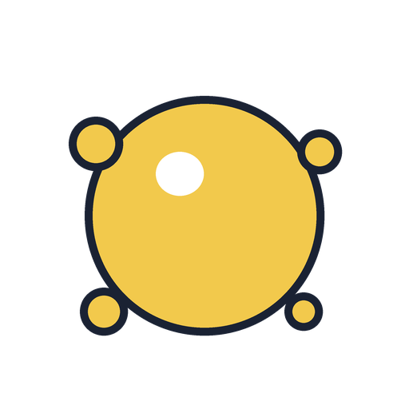  yellow
  green |   orange | 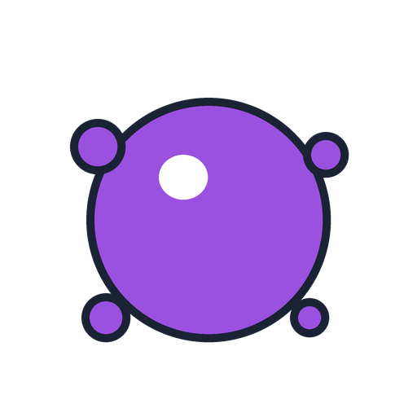  purple

