KiiTOS Kids Level 1 - Lesson 03
My Family
30-minute lesson plan for ages 4-7
Lesson at a glance
Item | Detail
Track | Kids
Level | 1 - First Steps
Age | 4-7
Group | 1-8 learners
Time | 30 minutes
Reading | Not required
Materials | Picture cards; paper and pencil

1. Lesson aim
Learners name family members and introduce them with one short sentence.
2. Learning objectives
- Understand and say family words: family, mother, father, sister, brother, baby.
- Say "This is my mother.".
- Point to a family picture and name one person.
3. Teaching principles
Every lesson in this series follows the same eight principles. They are part of the lesson, not extra advice.
1. One new word at a time. Secure it before adding another.
2. See it, hear it, say it, do it. Use a picture, a sound, your voice and a movement.
3. Repeat each word 5-7 times. Vary the way you repeat; do not only drill.
4. Move every 5 minutes. Young learners learn through the body.
5. No translation. Use pictures, gestures and sounds.
6. Praise effort, not perfect pronunciation. Confidence comes before accuracy.
7. Give one short instruction. Model it; do not explain it.
8. Finish with a win. End with something the learner can do alone.
4. 30-minute lesson flow
Time | Stage | Teacher does | Learners do
0-3 | Welcome | Wave and say: "Hello! I'm ___." | Wave back and say "Hello!".
3-8 | Warm-up | Point to yourself and to a family picture. | Point and say: This is me.
8-14 | Vocabulary A | Show family, mother, father. See, hear, say, do. | Repeat and make the action.
14-19 | Vocabulary B | Show sister, brother, baby. Review A. | Repeat and make the action.
19-24 | Activity | Run Family point with the cards. | Point and say: This is my ___.
24-28 | Sentence practice | Point and say: "This is my mother." | Point and say: "This is my ___."
28-30 | Wrap-up | Review two words. Praise. Say goodbye. | Say two words and wave goodbye.

5. Vocabulary plan
Six words only. Each word has a sound or action and one sentence. The action is the memory hook.
Word | Sound or action | Target sentence
family | arms around | This is my family.
mother | wave | This is my mother.
father | wave | This is my father.
sister | wave | This is my sister.
brother | wave | This is my brother.
baby | rock arms | This is the baby.

6. Classroom activity
Activity: Family point
The teacher says one family word. Learners point to the matching picture and say "This is my ___." Repeat with all six words. Then learners point to a family photo or drawing and name one person.
- Teacher says a family word.
- Point to the person.
- Say: This is my ___.
- Take turns.
7. Materials and low-resource version
- Six picture cards: family, mother, father, sister, brother, baby.
- A family drawing or photo (optional).
- Paper and a pencil for the teacher's notes.
If resources are limited:
- No printer: draw six simple faces on paper.
- No projector: hold the cards or show them on a phone.
- No photo: learners can point to the picture cards.
- Black-and-white copies are fine. Use clear faces.
8. Success criteria
- Points to the right family member when heard: 5 of 6.
- Says each word with support; approximate pronunciation is fine.
- Says "This is my ___." with one person.
- Joins the hello and goodbye routine.
9. Differentiation
- Shy learner: point first, then whisper, then say the word.
- Struggling: keep four words: family, mother, father, baby.
- Ready: ask "Who is this?" and add "This is my ___.".
- Large group: use whole-class pointing and family-card pairs.
10. Home practice
Draw your family. Say: This is my ___.
11. Originality and license
This lesson plan is an original work by Golden Word / KiiTOS. Free for personal, family, and classroom use. Not for resale. Keep this notice when you share.
Copyright 2026 iCare Edutainment | Honor U Ministry Ltd.
hello@kiitos.world
12. Format standard used for this kit
- Slides: 16:9. Title 40-44pt. Body 28pt minimum. 5-6 lines per slide.
- Lesson plan: A4. Margins 2cm. Body 12pt minimum. Headings 16-20pt.
- Every page: legal line, KiiTOS Kids Level 1, KiiTOS icon and page number.
- High contrast. Black-and-white printing must stay readable.
- No colour-only meaning. No external exam brands. English only.

Appendix: Picture cards (original)
Six original flat icons for this lesson. Use them as picture cards, or replace them with final art. No copyrighted characters.
  family | 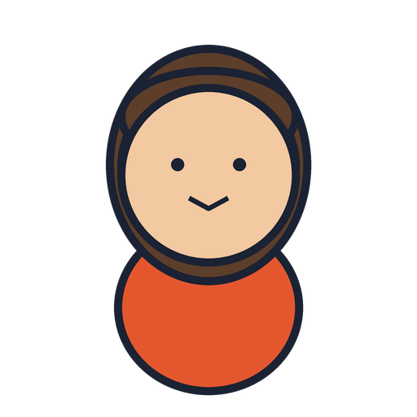  mother |   father
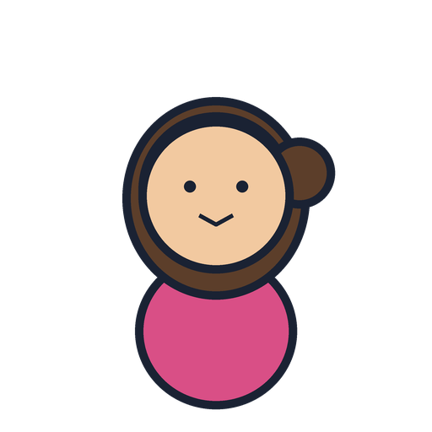  sister |   brother | 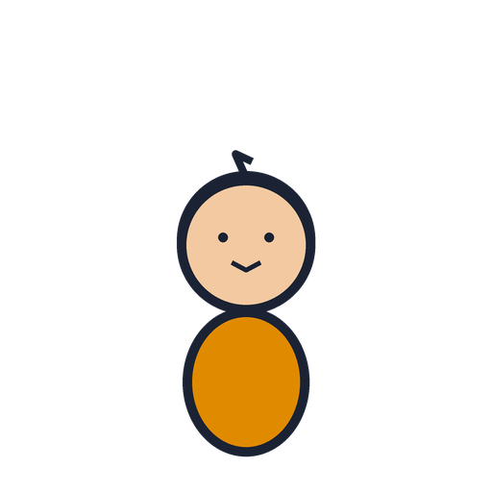  baby

