KiiTOS Kids Level 1 - Lesson 02
Big and Small
30-minute lesson plan for ages 4-7
Lesson at a glance
Item | Detail
Track | Kids
Level | 1 - First Steps
Age | 4-7
Group | 1-8 learners
Time | 30 minutes
Reading | Not required
Materials | Picture cards; paper and pencil

1. Lesson aim
Learners compare two animals and say which one is big or small.
2. Learning objectives
- Understand and say big and small.
- Say "The bear is big." and "The cat is small.".
- Compare two animals with support.
3. Teaching principles
Every lesson in this series follows the same eight principles. They are part of the lesson, not extra advice.
1. One new word at a time. Secure it before adding another.
2. See it, hear it, say it, do it. Use a picture, a sound, your voice and a movement.
3. Repeat each word 5-7 times. Vary the way you repeat; do not only drill.
4. Move every 5 minutes. Young learners learn through the body.
5. No translation. Use pictures, gestures and sounds.
6. Praise effort, not perfect pronunciation. Confidence comes before accuracy.
7. Give one short instruction. Model it; do not explain it.
8. Finish with a win. End with something the learner can do alone.
4. 30-minute lesson flow
Time | Stage | Teacher does | Learners do
0-3 | Welcome | Wave and say: "Hello! I'm ___." | Wave back and say "Hello!".
3-8 | Warm-up | Stretch big, crouch small. Model the actions. | Copy the actions and say big, small.
8-14 | Vocabulary A | Show big, small, bear. Compare the cards. | Repeat and show the size with hands.
14-19 | Vocabulary B | Show cat, rabbit, dog. Review big and small. | Repeat and compare the animals.
19-24 | Activity | Run Big or small? with the cards. | Say big or small and sort the cards.
24-28 | Sentence practice | Point and say: "The bear is big." | Point and say: "The ___ is ___."
28-30 | Wrap-up | Review two words. Praise. Say goodbye. | Say two words and wave goodbye.

5. Vocabulary plan
Six words only. Each word has a sound or action and one sentence. The action is the memory hook.
Word | Sound or action | Target sentence
big | arms wide | The bear is big.
small | fingers together | The cat is small.
bear | big arms | The bear is big.
cat | small paws | The cat is small.
rabbit | hop | The rabbit is small.
dog | one hand like a paw | The dog is big.

6. Classroom activity
Activity: Big or small?
The teacher shows two animal cards. Learners say "big" or "small" and make the shape with their hands. Sort the cards into two groups. Repeat with all six animals.
- Teacher shows two animal cards.
- Say: big or small.
- Put the cards in two groups.
- Praise every try.
7. Materials and low-resource version
- Six animal picture cards: cat, dog, bird, fish, rabbit, bear.
- Two boxes, hoops or paper circles for sorting (optional).
- Paper and a pencil for the teacher's notes.
If resources are limited:
- No printer: draw two big animals and two small animals.
- No projector: hold the cards or show them on a phone.
- No boxes: make two piles on the floor.
- Black-and-white copies are fine. Use clear sizes.
8. Success criteria
- Points to the big or small animal when asked: 5 of 6.
- Says big and small with support.
- Says "The bear is big." or "The cat is small.".
- Joins the warm-up and goodbye routine.
9. Differentiation
- Shy learner: show the size with hands before speaking.
- Struggling: compare only two animals: bear and cat.
- Ready: add "Is the rabbit big or small?".
- Large group: hold up two cards and ask the whole class to choose.
10. Home practice
Find one big thing and one small thing at home. Say: big, small.
11. Originality and license
This lesson plan is an original work by Golden Word / KiiTOS. Free for personal, family, and classroom use. Not for resale. Keep this notice when you share.
Copyright 2026 iCare Edutainment | Honor U Ministry Ltd.
hello@kiitos.world
12. Format standard used for this kit
- Slides: 16:9. Title 40-44pt. Body 28pt minimum. 5-6 lines per slide.
- Lesson plan: A4. Margins 2cm. Body 12pt minimum. Headings 16-20pt.
- Every page: legal line, KiiTOS Kids Level 1, KiiTOS icon and page number.
- High contrast. Black-and-white printing must stay readable.
- No colour-only meaning. No external exam brands. English only.

Appendix: Picture cards (original)
Six original flat icons for this lesson. Use them as picture cards, or replace them with final art. No copyrighted characters.
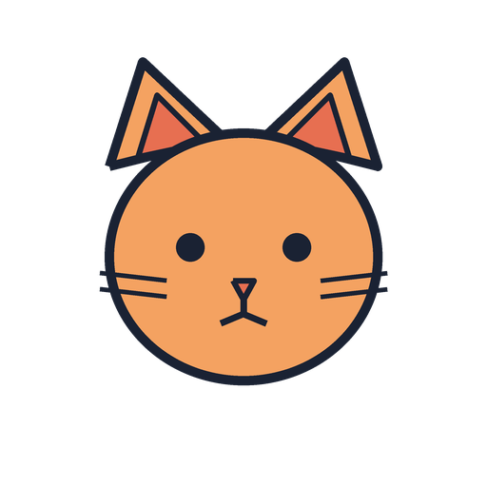  cat | 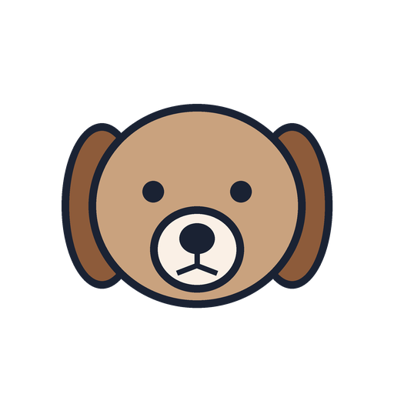  dog | 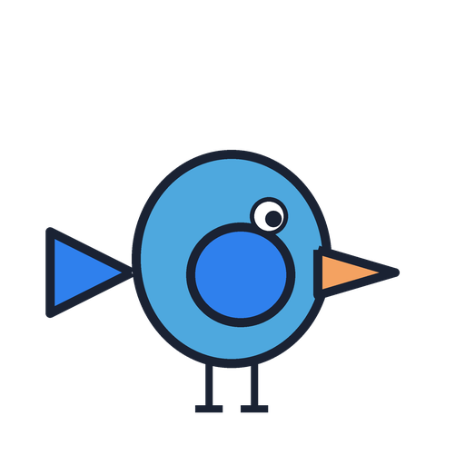  bird
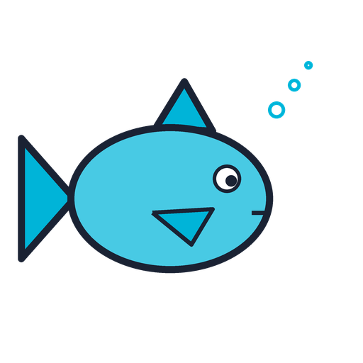  fish | 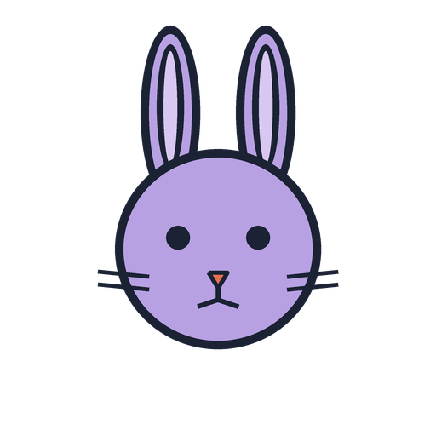  rabbit | 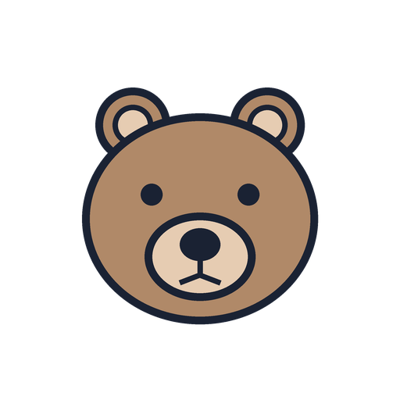  bear

