KiiTOS Kids Level 1 - Lesson 01
My First Animals
30-minute lesson outline for ages 4-7
Lesson at a glance
Item | Detail
Track | Kids
Level | 1 - First Steps
Age | 4-7
Group | 1-8 learners
Time | 30 minutes
Reading | Not required
Materials | Six picture cards, soft ball (optional)

1. Lesson aim
Learners recognise and say six animal words, and use one short sentence: I see a ___.
2. Learning objectives
- Understand and say six animal words: cat, dog, bird, fish, rabbit, bear.
- Answer "What is it?" with one animal word.
- Point to a picture and say "I see a ___."
3. Teaching principles
Every lesson in this series follows the same eight principles. They are part of the lesson, not extra advice.
1. One new word at a time. Secure it before adding another.
2. See it, hear it, say it, do it. Use a picture, a sound, your voice and a movement.
3. Repeat each word 5-7 times. Vary the way you repeat; do not only drill.
4. Move every 5 minutes. Young learners learn through the body.
5. No translation. Use pictures, gestures and animal sounds.
6. Praise effort, not perfect pronunciation. Confidence comes before accuracy.
7. Give one short instruction. Model it; do not explain it.
8. Finish with a win. End with something the learner can do alone.
4. 30-minute lesson flow
Time | Stage | Teacher does | Learners do
0-3 | Welcome | Wave and say: "Hello! I'm ___." | Wave back and say "Hello!"
3-8 | Warm-up | Make animal sounds. Model hop, fly, swim. | Copy the sounds and the actions.
8-14 | Vocabulary A | Show cat, dog, bird. See, hear, say, do. | Repeat and make the action.
14-15 | Quick review | Point to the three cards. | Say the word for each card.
15-19 | Vocabulary B | Show fish, rabbit, bear. Same routine. | Repeat and make the action.
19-24 | Mini-game | Run Listen & Tap: Animals, or the card version. | Listen and tap or point to the right animal.
24-28 | Sentence practice | Point and say: "I see a cat." | Point and say: "I see a ___."
28-30 | Wrap-up | Review two words. Praise. Say goodbye. | Say two words and wave goodbye.

5. Vocabulary plan
Six words only. Each word has a sound, an action and one sentence. The action is the memory hook.
Word | Sound and action | Target sentence
cat | meow - hands like whiskers | I see a cat.
dog | woof - one hand like a paw | I see a dog.
bird | tweet - arms like wings | I see a bird.
fish | blub - hands swimming | I see a fish.
rabbit | hop - two fingers like ears | I see a rabbit.
bear | growl - big arms | I see a bear.

6. Mini-game brief for #07
Game name: Listen & Tap: Animals
Owner: #07
Learning target: Six animal words and the sentence "I see a ___."
Mechanic: The learner hears an animal sound and taps the matching picture from three large cards.
Rounds: Six rounds. One sound per round. No timer at Level 1.
Feedback: Correct: the picture grows and the word plays. Wrong: a gentle shake, the correct card glows, and the learner tries again.
Accessibility: Large tap targets. Audio replay. Picture plus word label. Works on a phone. No login. No personal data.
Success: Five of six correct. A short review list at the end.
Handoff: #10 supplies the word list, sound descriptions and success criteria. #07 owns mechanics, art, audio and feedback. The game must work without reading, without a timer and without a login.
7. Materials and low-resource version
- Six picture cards: cat, dog, bird, fish, rabbit, bear.
- A soft ball or a rolled paper ball (optional).
- A phone or tablet for the mini-game (optional).
- Paper and a pencil for the teacher's notes.
If resources are limited:
- No printer: draw six animals on paper or use toys.
- No projector: hold the cards or show them on a phone.
- No internet: the teacher makes the sounds; use the cards.
- No game: play the same game with cards on the floor.
- Black-and-white copies are fine. Use big, clear pictures.
8. Success criteria
- Points to the right animal when heard: 5 of 6.
- Says each word with support; approximate pronunciation is fine.
- Says "I see a ___." with one animal.
- Joins the hello and goodbye routine.
- No formal test. No score is shown to children.
Differentiation
- Shy learner: point first, then whisper, then say the word.
- Struggling: keep three animals only: cat, dog, bird.
- Ready: ask "Is it big or small?" and add one new answer.
- Large group: use whole-class pointing, chants and pair turns.
9. Series map and next lesson
No. | Lesson | Focus
01 | My First Animals | Six animals and "I see a ___."
02 | Big and Small | Recycle the animals; big and small.
03 | My Family | Mother, father, sister, brother.
04 | Colours Everywhere | Red, blue, yellow, green.

Next pack: 02 Big and Small. It recycles the same six animals and adds two describing words: big and small. Same 30-minute format.
10. Originality and license
- #10 owns: outline, objectives, vocabulary, success criteria.
- #07 owns: game mechanics, art, audio, feedback.
- #06 owns: final review, PDF/PPTX/DOCX generation, publish.
- Original work. No copyrighted characters, songs or images.
- Free for family and classroom use. Not for resale.
This lesson outline is an original work by Golden Word / KiiTOS. Free for personal, family, and classroom use. Not for resale. Keep this notice when you share.
© 2026 iCare Edutainment | Honor U Ministry Ltd.
hello@kiitos.world
11. Format standard used for this pack
- PPTX: 16:9. Title 40-44pt. Body 28pt minimum. 5-6 lines per slide.
- DOCX: A4. Margins 2cm. Body 12pt minimum. Headings 16-20pt.
- Every page: legal line, KiiTOS Kids Level 1, KiiTOS icon and page number.
- High contrast. Black-and-white printing must stay readable.
- No colour-only meaning. No external exam brands. English only.

Appendix: Picture cards (original)
Six original flat icons for this lesson. Use them as picture cards, or replace them with final art. No copyrighted characters.
  cat | 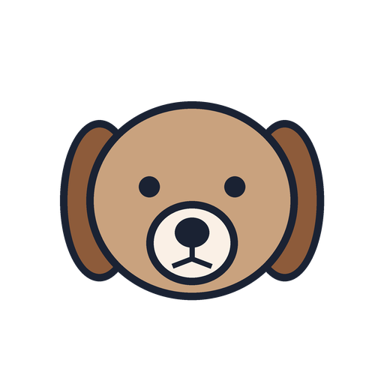  dog | 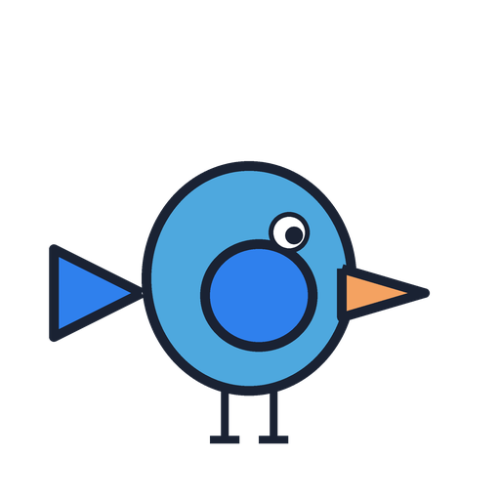  bird
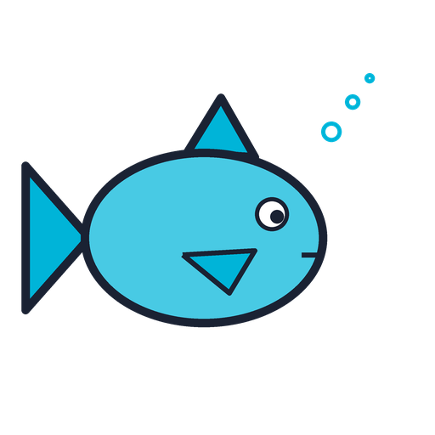  fish | 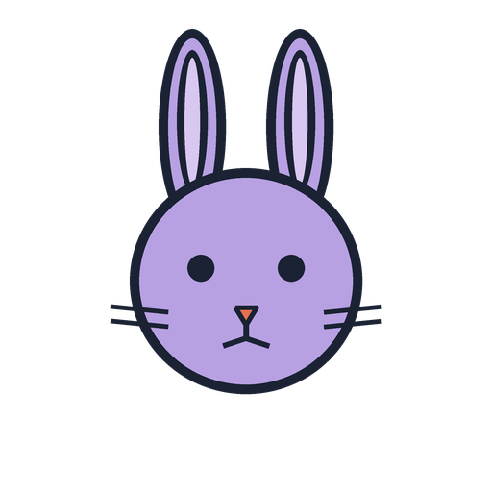  rabbit | 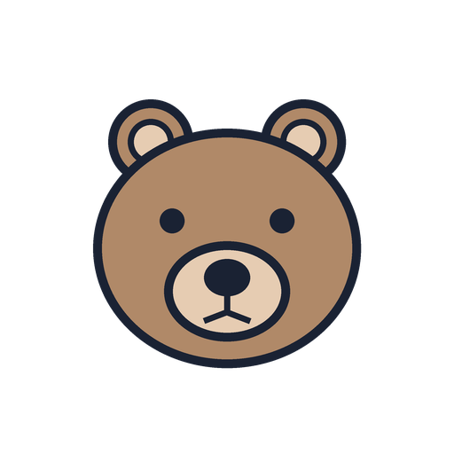  bear

