KiiTOS Kids Level 1 - Lesson 01
My First Animals
30-minute lesson plan for ages 4-7
Lesson at a glance
Item | Detail
Track | Kids
Level | 1 - First Steps
Age | 4-7
Group | 1-8 learners
Time | 30 minutes
Reading | Not required
Materials | Picture cards; paper and pencil

1. Lesson aim
Learners recognise and say six animal words, and use one short sentence: I see a ___.
2. Learning objectives
- Understand and say six animal words: cat, dog, bird, fish, rabbit, bear.
- Answer "What is it?" with one animal word.
- Point to a picture and say "I see a ___".
3. Teaching principles
Every lesson in this series follows the same eight principles. They are part of the lesson, not extra advice.
1. One new word at a time. Secure it before adding another.
2. See it, hear it, say it, do it. Use a picture, a sound, your voice and a movement.
3. Repeat each word 5-7 times. Vary the way you repeat; do not only drill.
4. Move every 5 minutes. Young learners learn through the body.
5. No translation. Use pictures, gestures and sounds.
6. Praise effort, not perfect pronunciation. Confidence comes before accuracy.
7. Give one short instruction. Model it; do not explain it.
8. Finish with a win. End with something the learner can do alone.
4. 30-minute lesson flow
Time | Stage | Teacher does | Learners do
0-3 | Welcome | Wave and say: "Hello! I'm ___." | Wave back and say "Hello!".
3-8 | Warm-up | Make animal sounds. Model hop, fly, swim. | Copy the sounds and the actions.
8-14 | Vocabulary A | Show cat, dog, bird. See, hear, say, do. | Repeat and make the action.
14-19 | Vocabulary B | Show fish, rabbit, bear. Review A. | Repeat and make the action.
19-24 | Activity | Run Listen and point with the cards. | Listen and point to the right animal.
24-28 | Sentence practice | Point and say: "I see a cat." | Point and say: "I see a ___."
28-30 | Wrap-up | Review two words. Praise. Say goodbye. | Say two words and wave goodbye.

5. Vocabulary plan
Six words only. Each word has a sound or action and one sentence. The action is the memory hook.
Word | Sound or action | Target sentence
cat | meow - hands like whiskers | I see a cat.
dog | woof - one hand like a paw | I see a dog.
bird | tweet - arms like wings | I see a bird.
fish | blub - hands swimming | I see a fish.
rabbit | hop - two fingers like ears | I see a rabbit.
bear | growl - big arms | I see a bear.

6. Classroom activity
Activity: Listen and point
The teacher says one animal word. Learners point to the matching picture card. Repeat with all six words. Then swap: a learner says a word and the group points.
- Teacher says an animal word.
- Learners point to the picture.
- Say the word together.
- Praise every try.
7. Materials and low-resource version
- Six picture cards: cat, dog, bird, fish, rabbit, bear.
- A soft ball or a rolled paper ball (optional).
- Paper and a pencil for the teacher's notes.
If resources are limited:
- No printer: draw six animals on paper or use toys.
- No projector: hold the cards or show them on a phone.
- No internet: the teacher makes the sounds; use the cards.
- Black-and-white copies are fine. Use big, clear pictures.
8. Success criteria
- Points to the right animal when heard: 5 of 6.
- Says each word with support; approximate pronunciation is fine.
- Says "I see a ___" with one animal.
- Joins the hello and goodbye routine.
9. Differentiation
- Shy learner: point first, then whisper, then say the word.
- Struggling: keep three animals only: cat, dog, bird.
- Ready: ask "What is it?" and add "Is it big or small?".
- Large group: use whole-class pointing, chants and pair turns.
10. Home practice
Point to three toys at home and say: I see a ___.
11. Originality and license
This lesson plan is an original work by Golden Word / KiiTOS. Free for personal, family, and classroom use. Not for resale. Keep this notice when you share.
Copyright 2026 iCare Edutainment | Honor U Ministry Ltd.
hello@kiitos.world
12. Format standard used for this kit
- Slides: 16:9. Title 40-44pt. Body 28pt minimum. 5-6 lines per slide.
- Lesson plan: A4. Margins 2cm. Body 12pt minimum. Headings 16-20pt.
- Every page: legal line, KiiTOS Kids Level 1, KiiTOS icon and page number.
- High contrast. Black-and-white printing must stay readable.
- No colour-only meaning. No external exam brands. English only.

Appendix: Picture cards (original)
Six original flat icons for this lesson. Use them as picture cards, or replace them with final art. No copyrighted characters.
  cat |   dog | 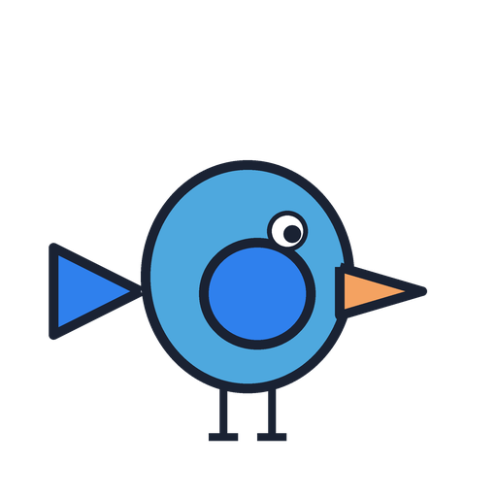  bird
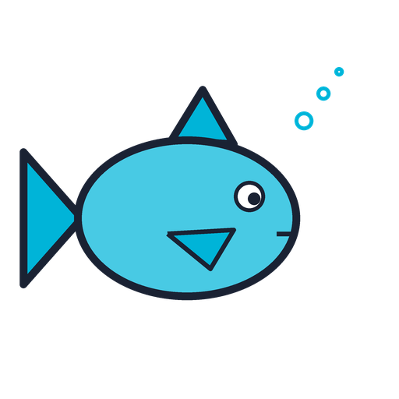  fish | 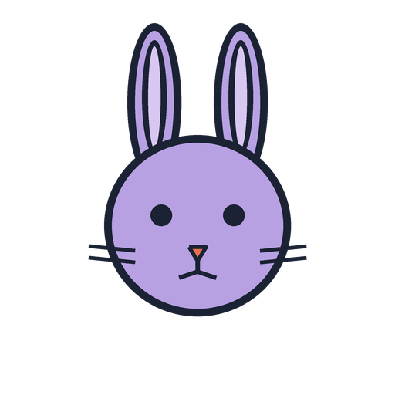  rabbit |   bear

